Laxmi Charitable Trust’s
Sheth L.U.J College of Arts & Sir M.V. College of Science and Commerce
Department of Information Technology (B.Sc.I.T Semester V)
Dot .Net Core and Progressive Web Application Practical
Practical – VI
Roll No.: T023 | Name: Som Mishra
Class: TYIT | Batch:B1
Date of Assignment: 30/07/2026 | Date/Time of Submission:30/07/2026

Part A - Program

- Create a simple website for a College Information Portal and convert it into a Progressive Web Application.
Code:
manifest.json:
{
"name": "HTML TO PWA",
"short_name": "HTP",
"start_url": "/",
"display": "standalone",
"icons": [
{
"src": "/icons/icon1.png",
"sizes": "128x128",
"type": "image/png",
"purpose": "any"
},
{
"src": "/icons/icon2.png",
"sizes": "512x512",
"type": "image/png",
"purpose": "any"
}
]
}

service-worker.js:
self.addEventListener("install", e => {
console.log("Service Worker installed");
});

self.addEventListener("fetch", e => {
e.responseWith(fetch(e.request));
});
_Layout.cshtml:
Inside the <head> section:
<link rel="manifest" href="/manifest.json" />

Before the closing </body> tag:
<script>
if('serviceWorker' in navigator){
navigator.serviceWorker.register('/service-worker.js');
}
</script>

Output:
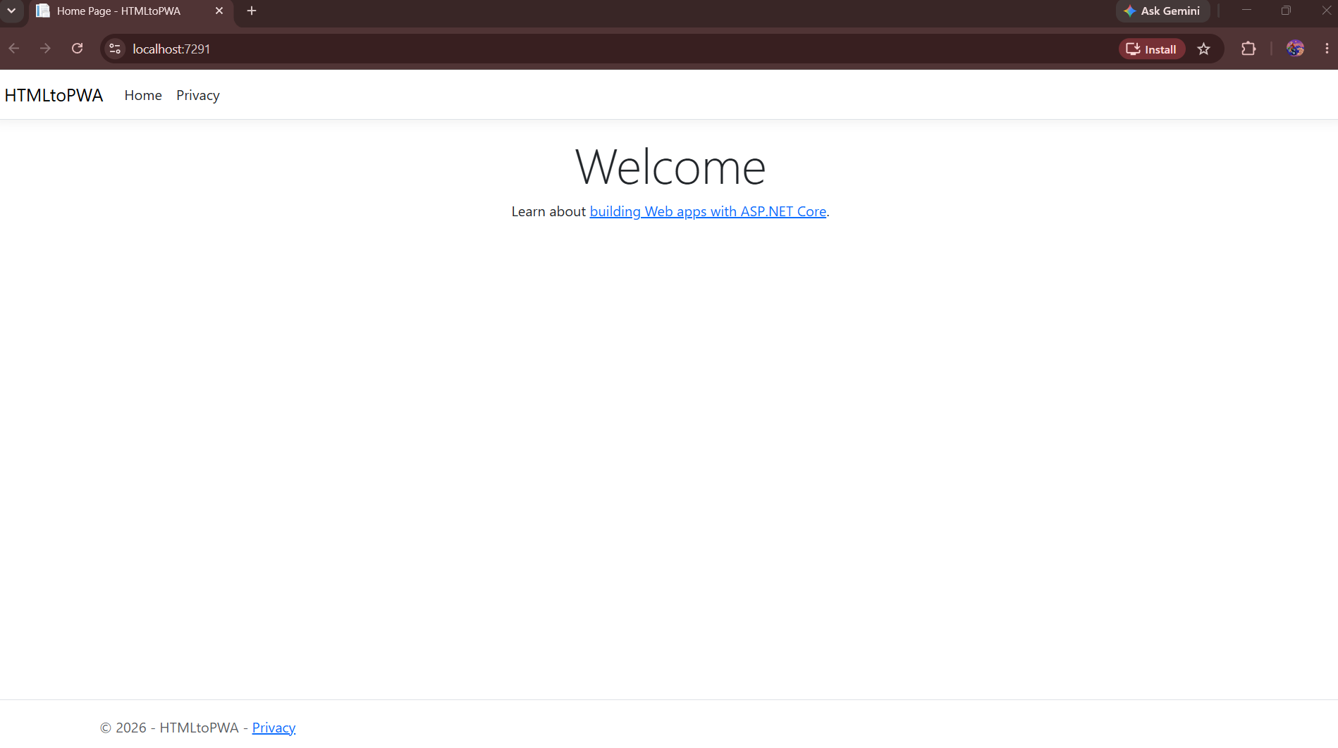
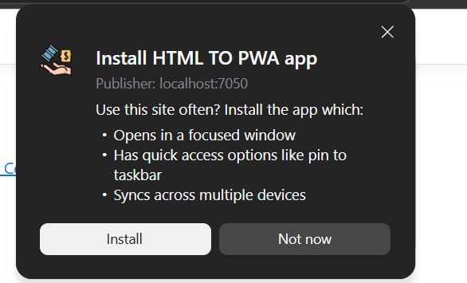

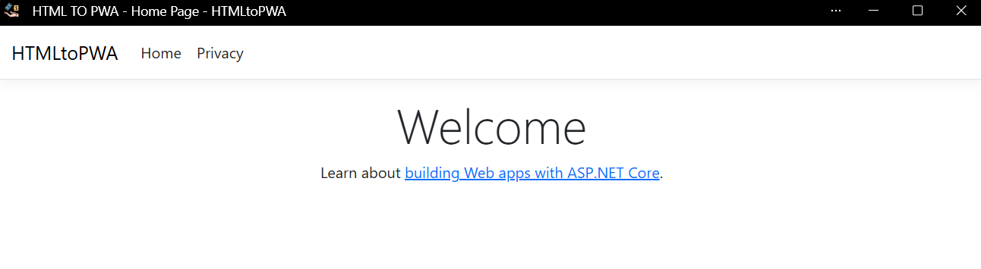

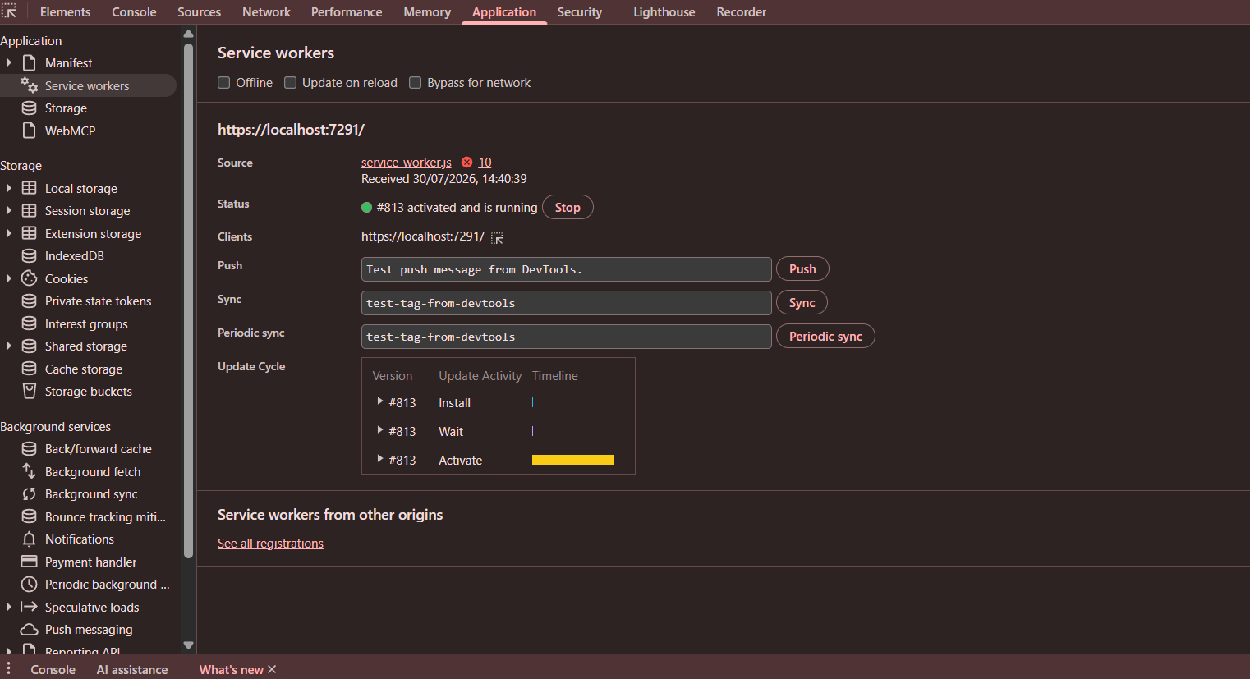

- Create a PWA that displays a custom offline page when the user is not connected to the internet.
Code:
offline.html :
<!DOCTYPE html>
<html>
<head>
<title>Offline</title>
</head>
<body style="text-align:center; margin-top:100px; font-family:Arial;">
<h1>You are Offline</h1>
</body>
</html>
service-worker.js :
const CACHE = "v1'";
self.addEventListener("install", event => {
event.waitUntil(
caches.open("offline-cache").then(cache => {
return cache.addAll([
"/",
"/offline.html"
]);
}));

console.log("Service workers Installed ")
});
self.addEventListener("fetch", event => {
event.respondWith(
fetch(event.request).catch(() => {
return caches.match("/offline.html");
})
);
});

Output:
